# Smart Student Enrollment and learning Portal (Phase 6)

**Goal:**

The goal of this project is to build a Salesforce-based Student Enrollment and Learning Portal that automates the complete admission process. It will streamline student inquiries, course enrollments, and fee tracking while reducing manual effort and delays. Automated notifications and reminders will improve communication with students and faculty. Overall, the system will enhance efficiency, accuracy, and reporting, ensuring a smoother enrollment experience for educational institutes.

**Problem Statement:**

Educational institutes face challenges in managing student inquiries, admissions, and course enrollments due to manual processes. This causes delays, missed follow-ups, and inefficiency. A Salesforce-based portal will automate lead capture, admissions, fee tracking, and notifications, ensuring faster enrollment and better reporting.

# Phase 6: User Interface Development

Phase 6 focuses on **User Interface (UI) Development** to make the Smart Student Enrollment and Learning Portal more user-friendly and interactive. In this phase, Lightning Record Pages, Lightning App Builder and dashboards were designed to provide an engaging and efficient experience for students, teachers, and administrators.

## ****Lightning Record Pages****

* Customized **Record Pages** for Students, Courses, and Batches.
* Added **related lists** for quick navigation to enrollments, fees, and batches.
* Improved record visibility with logically grouped sections.

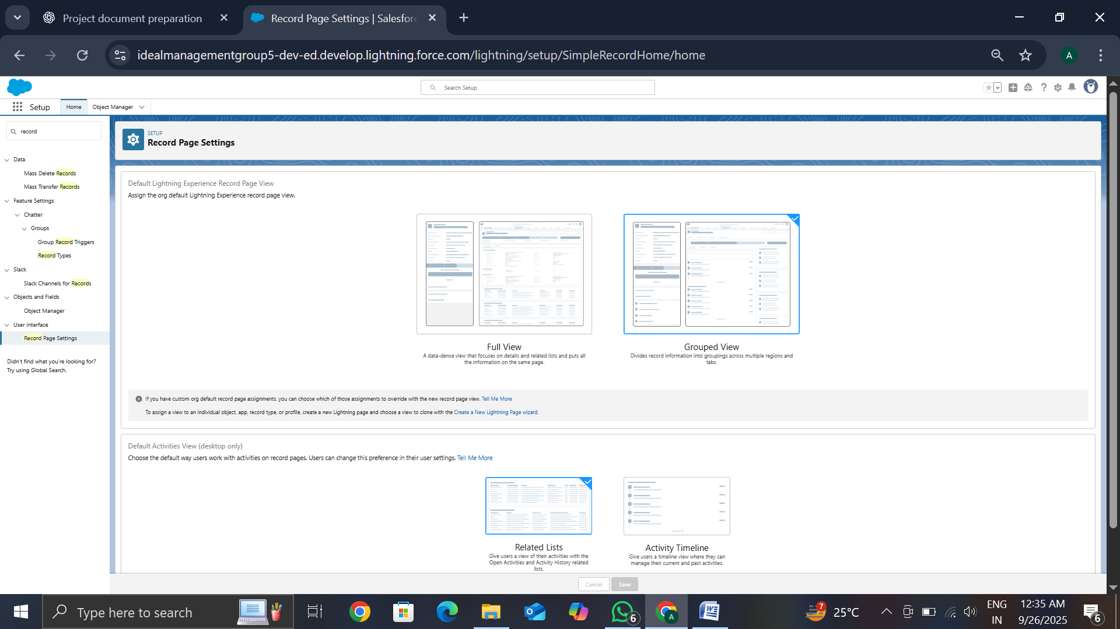

## ****Lightning App Builder****

* Used **Lightning App Builder** to design personalized record pages.
* Created **tabs and sections** to display important details like course info, fee tracking, and student data.
* Enhanced accessibility by making frequently used features more prominent.

**Home Page Layouts**

* Designed personalized home pages for different profiles using Lightning App Builder.
* Included key metrics, reports, dashboards, and quick actions for better efficiency.

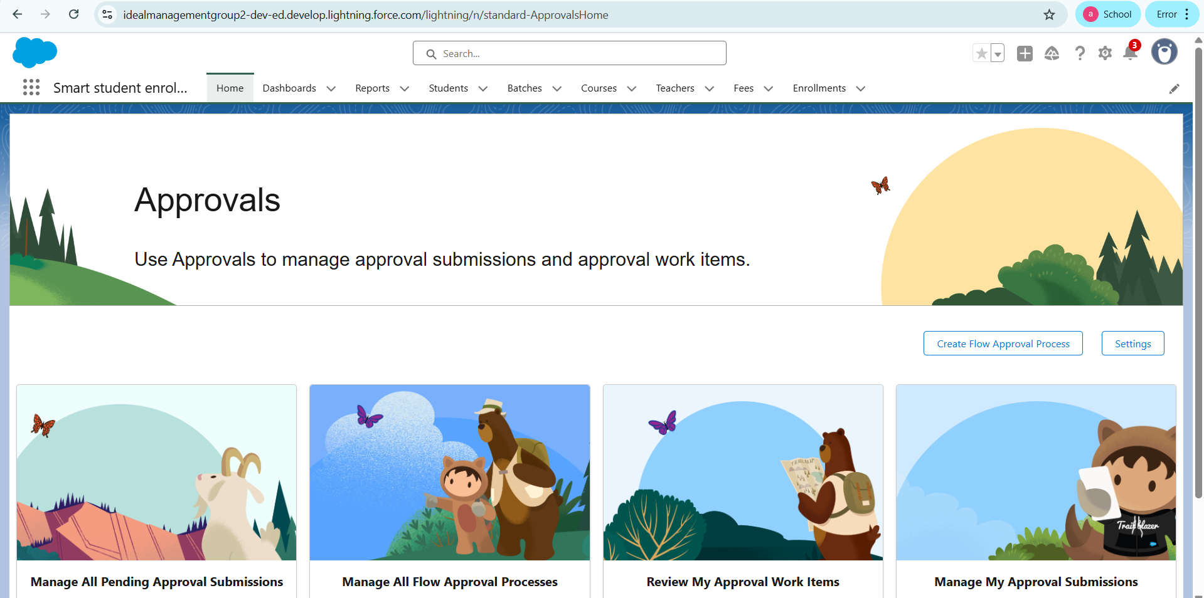

**Tabs**

* Configured object and custom tabs for easy access to relevant data.
* Organized tabs logically to align with user roles and workflows.

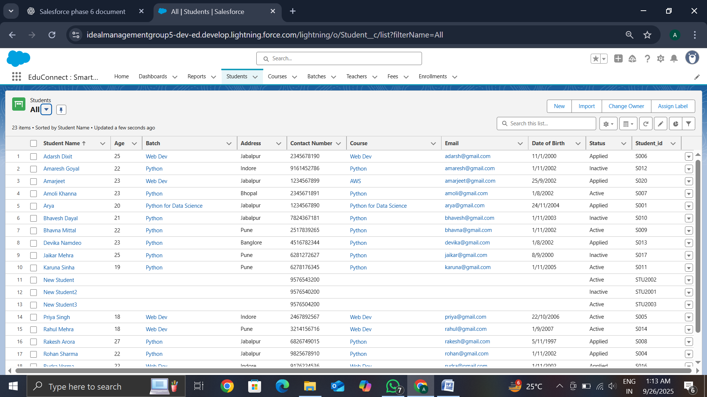

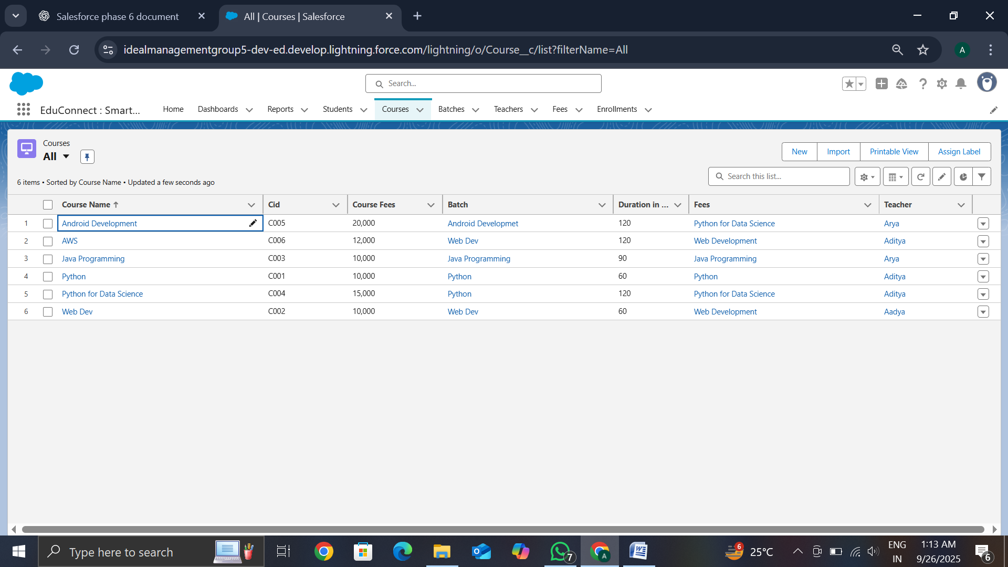

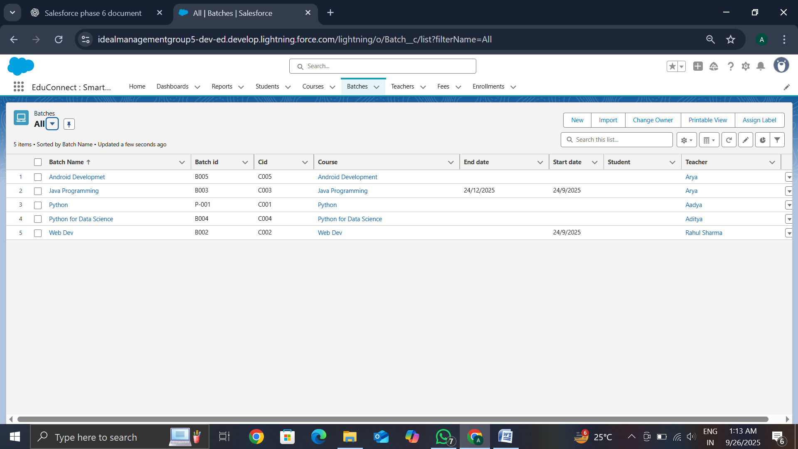

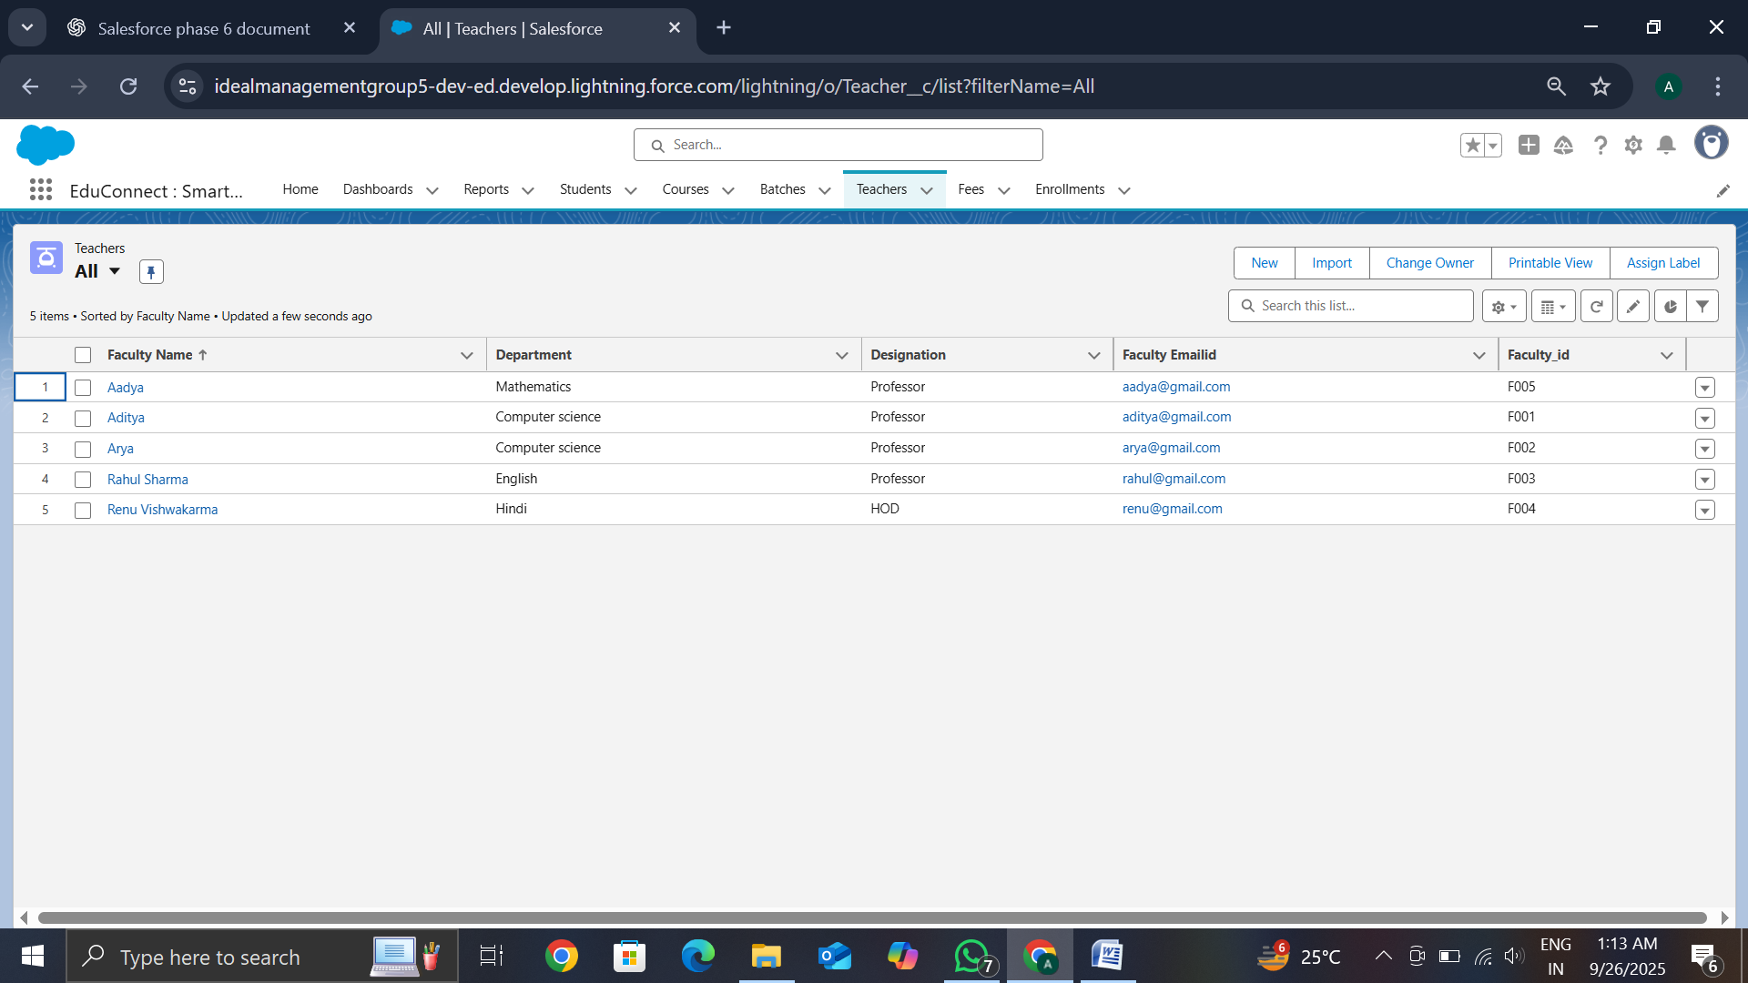

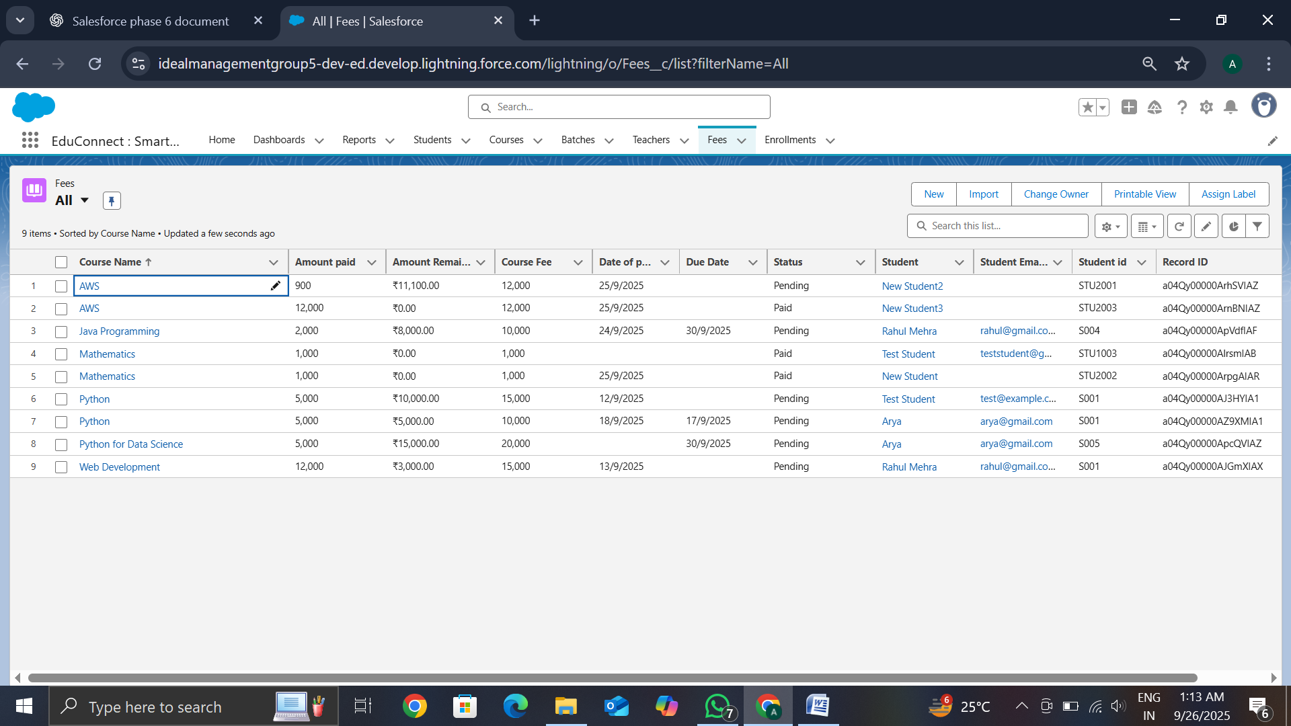

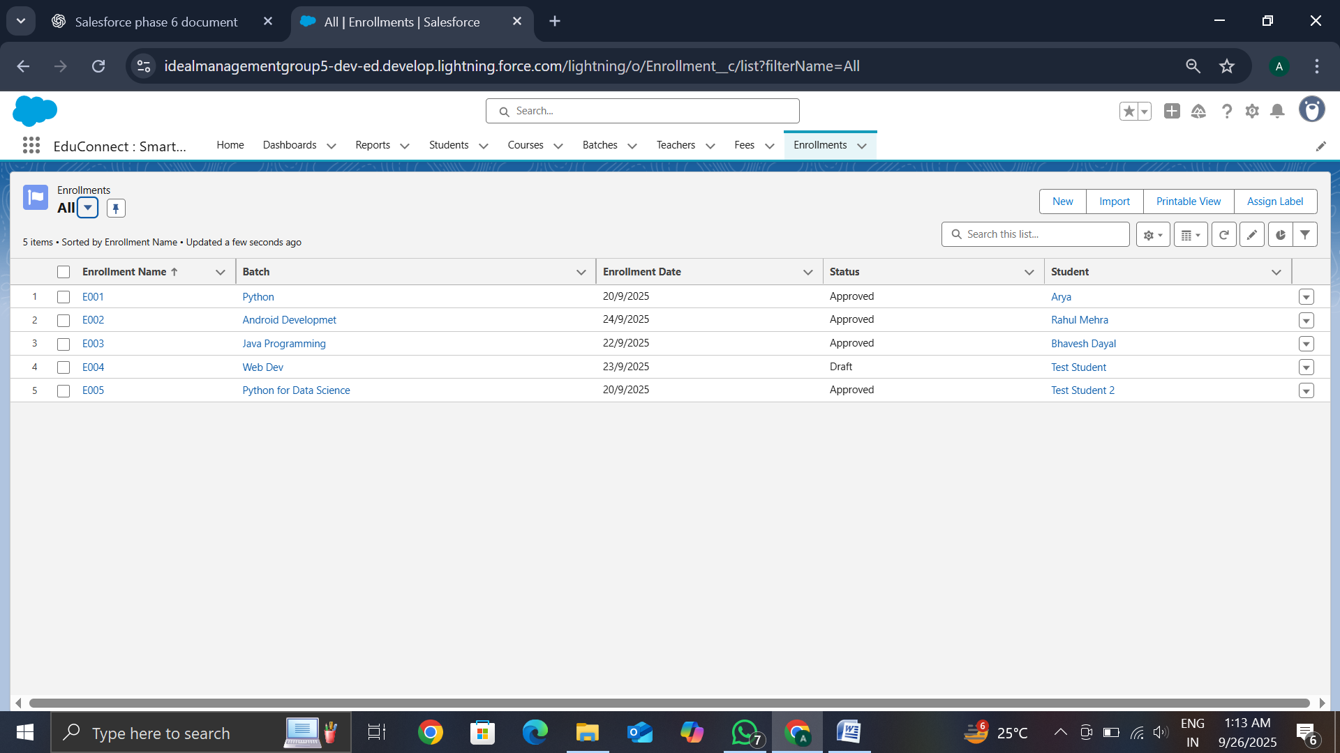

## ****Student Dashboard****

* Developed a **Student Dashboard** with quick links for admissions, course details, and fee status.
* Added **charts and visual indicators** to represent enrollment progress and fee payment history.
* Provided a **centralized view** for students to track their academic journey.

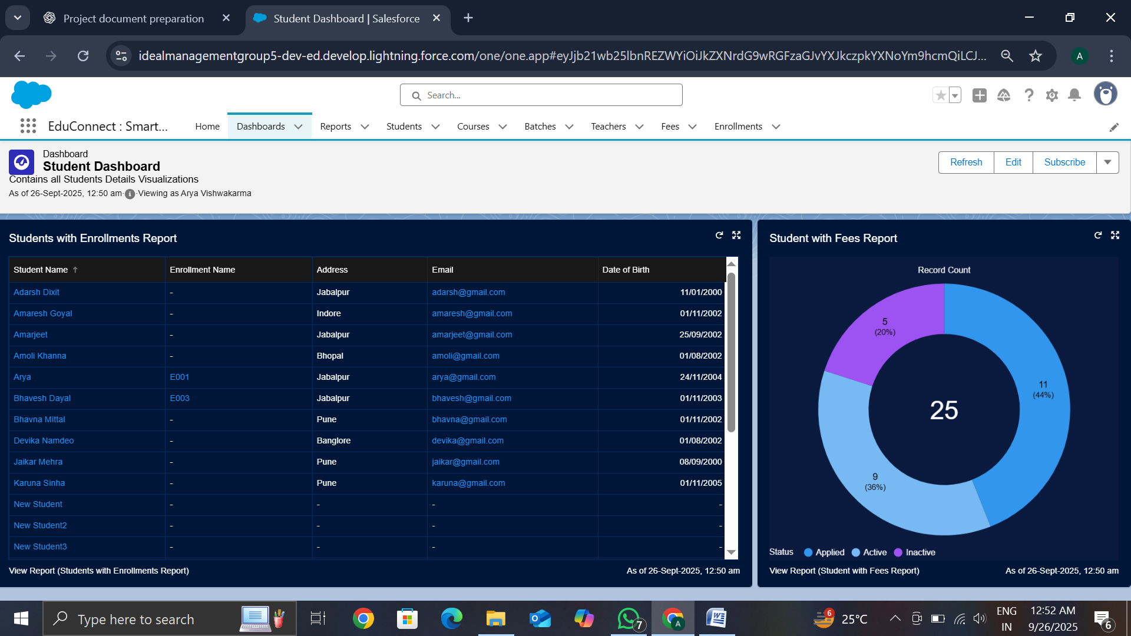

## ****Conclusion****

Phase 6 successfully improved the **user experience** of the CRM portal. By customizing record pages and building a student dashboard, the portal became more **interactive, responsive, and user-friendly**. This ensures students, faculty, and administrators can navigate and manage records efficiently.